Client Handbook: Build Your City (Focus App)
1. Introduction
- About the App: Build Your City (Focus) is a gamified productivity application built to help users combat smartphone addiction and improve digital well-being. By locked focus timers, users earn XP to construct a virtual city.
- Target Audience: This handbook serves as a comprehensive operational guide for two main parties:
  - Students (End Users): To manage focus sessions, build cities, and track personal well-being.
  - Counselors / Admins: To monitor student behaviors, analyze usage trends, and manage interventions.
2. System Requirements & Installation
2.1 Hardware & Software Requirements
- Android: Android 8.0 (Oreo) or above.
- iOS: iOS 13.0 or above.
- Network: Active internet connection (Wi-Fi or Mobile Data) is recommended for cloud synchronization, though core tracking functions support Offline Persistence (local storage caching via SharedPreferences).
2.2 Installation Steps (Android APK Deployment)
- Download the provided app-release.apk file to your device.
- Go to your device Settings > Security, and enable "Install from Unknown Sources".
- Open the downloaded file and tap Install.
- Launch the Focus app from your home screen.
3. Getting Started & Account Registration (Authentication & Sign Up)
3.1 Unified Access Gateway
To streamline user onboarding and maintain a high level of system integrity, our application utilizes a single gateway for both login and registration. Both regular students and counselors enter the system via this unified portal.
- Email-Only Account Creation: To ensure proper database mapping and enhanced backend security, the system exclusively accepts valid email formats (e.g., name@email.com). Tradtional alphanumeric usernames are strictly restricted.
- Password Toggle Feature: To prevent frustrating entry errors during password configuration or confirmation, users can tap the interactive Eye Icon on the right side of the input field to temporarily display or hide text characters.
- Invitation or Family Group Code (Optional): This field provides dynamic grouping logic upon account creation:
  - Student / Family Users: Users can input a unique code provided by their parents or group creators. Upon submission, the account is automatically linked to that specific family circle, allowing participation in the family leaderboards for competitive motivation.
  - Counselor Accounts: (If applicable) Administrative or institutional invitation codes can be processed here to automatically grant supervisor privileges and route the user to the correct administrative dashboard.
- Real-Time Validation Alerts: If a user submits an incorrectly formatted email or passwords that do not match, an instant Snackbar notification appears at the bottom of the screen to guide corrections immediately without forcing a full page reload.
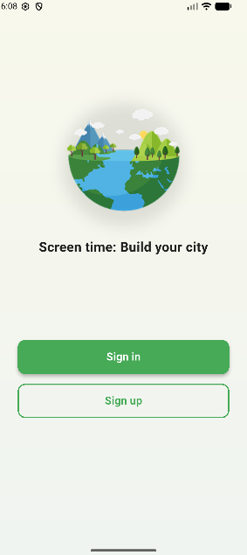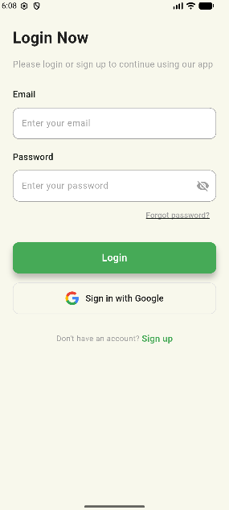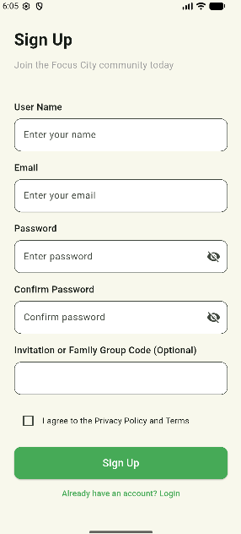
4. User Guide: Student Role
4.1 Navigating the Focus City Page
Upon entering the app, students land on the /main pathway, opening the Focus City Page.
- The City Grid: This interactive map renders your current virtual city.
- City Inventory: Swiping up the bottom sheet opens your inventory. Here, you can select and place unlocked structural assets onto the map using your accumulated XP.
4.2 Operating the Focus Timer & Anti-Cheat Penalties
- Select a desired focus duration on the circular/digital timer display.
- Tap Start Session to lock the screen.
- ⚠️ The Anti-Cheat Policy: The application actively tracks focus integrity. If a user exits or background-tasks the app during an active session, the focus_session_provider registers an unfulfilled state. A penalty will be applied, reducing your city's growth progress.
4.3 Family Leaderboards & Gamified Competition
- Group Synchronization: If a valid Family Group Code was provided during the signup phase, the user_profile.dart model automatically maps the student's unique identifier to their respective family group document in Cloud Firestore.
- Progress Tracking: Students can access the Leaderboard view to check their experience point (XP) rankings against other family members. This friendly competition leverages gamification to encourage users to maintain healthy offline habits.
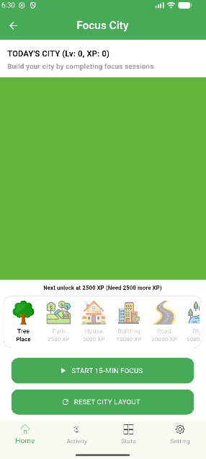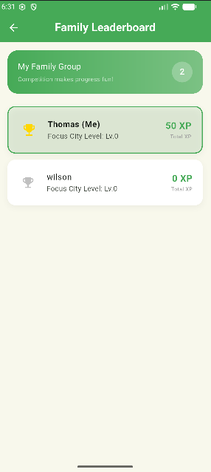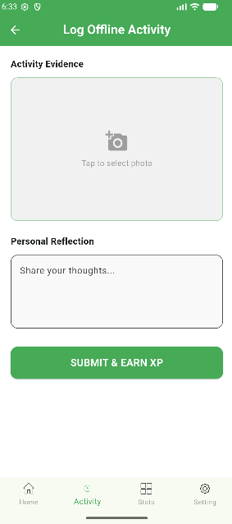
5.Admin Guide: Counselor Dashboard
5.1 Automatic Role-Based Routing
When an account flagged with the Counselor role in the Firestore backend logs in, the system completely bypasses the game modules and automatically routes the account to /counselor (Counselor Dashboard).
- Security Note: To ensure professionalism and data integrity, all city-building modules, inventories, and gamified features are strictly hidden and blocked for this role.
5.2 Student Monitoring & Statistics
Counselors are presented with a unified list of linked students:
- Clicking on any student name pulls up their reactive Statistics Dashboard.
- The dashboard populates custom Bar Charts and Line Graphs tracking daily app lock times, focus fulfillment rates, and mood trends over weekly and monthly periods.
5.3 Data Portability (Exporting Student Reports)
To back up or utilize records in external software (like Microsoft Excel), Counselors can leverage the data export module:
- Navigate to the targeted student profile or group summary page.
- Tap the Export Data icon.
- The firestore_service compiles all raw session records and outputs a securely formatted Tab-Separated Values (TSV) file directly to the device storage.

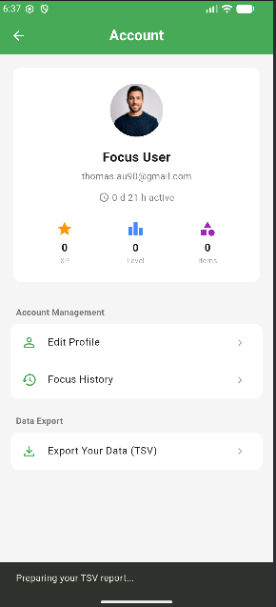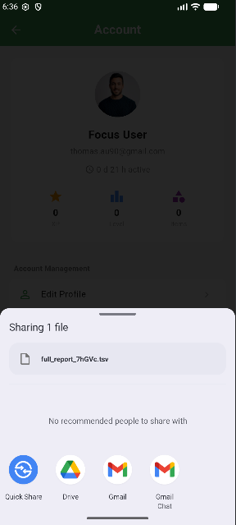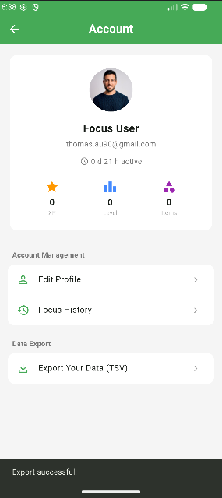
6.Troubleshooting & FAQs
Observed Issue / Snackbar Error | Root Cause | Recommended Action
"Invalid Email Format" | Input text does not contain @ or a legitimate domain suffix. | Re-enter a complete email address and use the Password Toggle to verify characters.
"Authentication Failed" | Incorrect password or role assignment error. | Double check authentication credentials. Contact the administrator if a role switch is required.
App features frozen / No data showing | The device has temporarily lost cellular or Wi-Fi connectivity. | Do not log out. The app has automatically engaged its Firebase Offline Persistence Layer. Continue your focus session normally; data is safely cached in SharedPreferences and will auto-sync to the cloud backend once network returns.
Missing Game Screen (For Counselors) | System security logic is performing as intended. | Counselors are restricted from game modules. The app automatically opens to the admin monitor stream only.

